|  |  |
| --- | --- |
|  | **Database Management Systems**  **BSCS-4**  **Department of Computer Science**  **Bahria University, Lahore Campus** |

**Assignment: [2]**

Date: Week 13, 11th December 2023

Name: AFFAN AHMAD

Roll No: 03-134221-003

|  |  |  |  |
| --- | --- | --- | --- |
| **Evaluation of CLO** | **Question Number** | **Marks** | **Obtained Marks** |
| **CLO: Analyze user requirements to design a database for the given scenarios** |  |  |  |
|  |  |  |
|  |  |  |
|  |  |  |
|  |  |  |
| **Total Marks** | | **20** |  |

**Question 1**

Write a short proposal on your project which must include introduction, scope of the project, why you choose this project (problem statement), and methodology diagram.

**Note:** proposal should not be more than 3 pages.

**Some examples of projects**

1. Blood Donation Management System
2. Cooking Recipe Website
3. Library Database Management System
4. Online Retail Database Software
5. Inventory Management System
6. Voice Commands Transport Enquiry System
7. Carbon-Emission Calculator
8. Railway Control System Database
9. Student Database Management
10. Hospital Management System
11. Payroll Management System
12. Grocery Store Sales
13. Food Service Database SQL Project
14. Power Bill Database System
15. Bus Booking System Mini Project

**Title: Modernizing Healthcare: A Hospital Management System**

**Introduction:**In the dynamic landscape of healthcare, the efficient management of hospital operations is crucial for providing quality patient care. Our proposed project, the "Hospital Management System," aims to streamline and automate various administrative and clinical processes within a healthcare facility. This system leverages technology to enhance efficiency, improve patient outcomes, and optimize resource utilization.

**Scope of the Project:**The scope of this project encompasses the development of a comprehensive Hospital Management System that integrates various modules, including patient registration, appointment scheduling, electronic health records (EHR), billing, pharmacy management, and staff administration. The system will provide a centralized platform for seamless communication and coordination among different departments, ensuring a smooth flow of information and enhancing the overall healthcare delivery process.

**Why We Choose This Project (Problem Statement):**The healthcare industry faces challenges such as manual paperwork, inefficient communication between departments, and difficulty in accessing patient information in a timely manner. Our project addresses these issues by introducing a modern Hospital Management System, aiming to eliminate paperwork, improve data accuracy, and enhance collaboration among healthcare professionals. By choosing this project, we aim to contribute to the modernization of healthcare facilities, leading to improved patient care and operational efficiency.

**Methodology Diagram:**

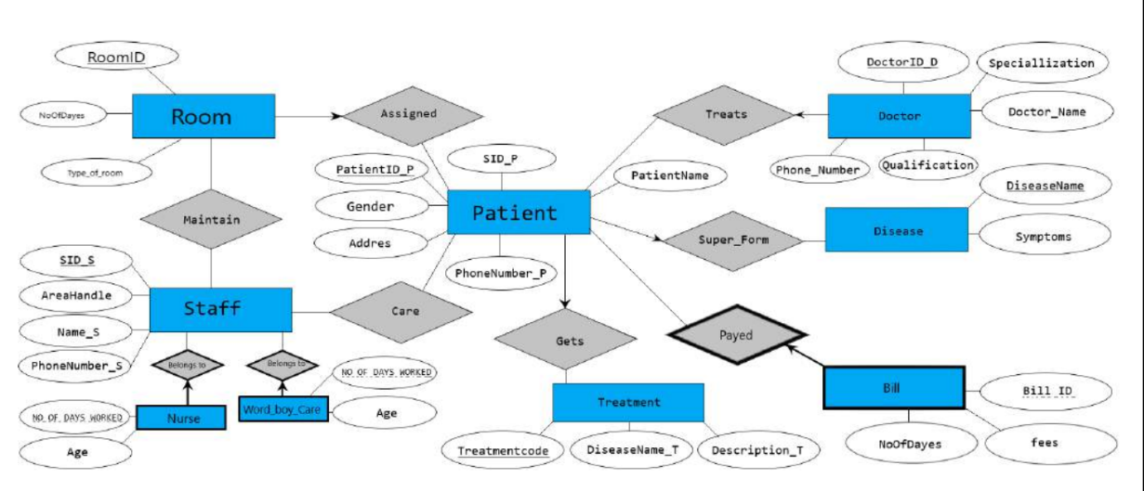

The methodology diagram outlines the key steps in our project:.

* **Requirement Analysis:** Collaborate with healthcare professionals to identify specific needs and requirements for each module of the Hospital Management System.
* **System Design:** Plan the architecture and design of the system, considering scalability, security, and user interface design.
* **Database Design:** Create a robust and secure database schema for storing patient information, appointments, medical records, and other relevant data.
* **Development:** Implement each module of the system using appropriate technologies, ensuring integration and compatibility.
* **Testing:** Conduct thorough testing, including unit testing, integration testing, and user acceptance testing, to ensure the system's reliability and accuracy.
* **Deployment:** Roll out the system in a phased manner, ensuring minimal disruption to hospital operations.
* **Training and Support:** Provide training sessions for hospital staff on using the system and establish a support mechanism for ongoing assistance.

**Conclusion:**The Hospital Management System project addresses the critical need for modernizing healthcare administration and improving patient care. By implementing this system, we aim to contribute to the efficiency and effectiveness of healthcare facilities, ultimately enhancing the overall healthcare experience for both patients and healthcare professionals.